
Network User Guide
Training Booklet
Chance Robson | 12/2/25 | JustIT

Contents
Adding Devices to the Network 2
Adding a Device with a Static IP Address 2
Adding a Device Using Dynamic IP (DHCP) 3
Connecting a Device Using a Cable 4
Connecting a Device Wirelessly 5
IoT Devices 6
Adding IoT Devices 6
Using the IoT Management App 7
Common IoT App Features 7

Adding Devices to the Network

Adding a Device with a Static IP Address
A static IP address is manually typed in and never changes.
Used for important devices such as:
- Printers
- IoT Server
- Critical PCs
Steps:
- Turn on the device and open the Network Settings menu.
- Select Manual / Static IP configuration.
- Enter the details provided by your IT team, for example:
  - IP Address: 192.168.25.xxx
  - Subnet Mask: 255.255.255.0
  - Gateway: 192.168.25.254
  - DNS Server: 192.168.25.1
- Click Save or Apply.
- Restart the device if required.
How do you know it worked?
It should appear like this. 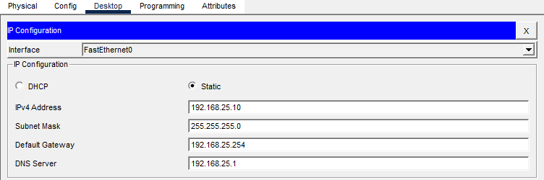
Tip:
- To test the connection, Try to open a webpage. For example https://www.justit.co.uk
If that doesn’t work, Contact IT Support

Adding a Device Using Dynamic IP (DHCP)
A dynamic IP address is automatically given by the wireless router.
Suitable for:
- Laptops
- Smartphones
- Most IoT devices
- Hot-desk computers

Steps:
- Open Network Settings.
- Choose Automatic / DHCP.
- Connect the device to the network (wired or wireless).
- It will automatically get an IP address from the router.

How do you know it worked?
It should appear like this
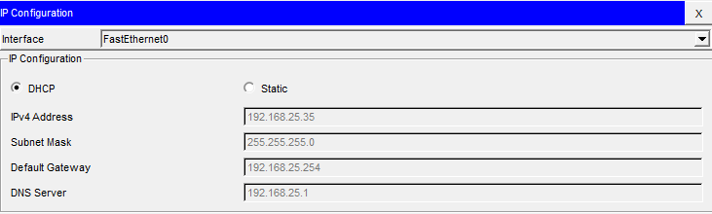
Tip:
- To test the connection, Try to open a webpage. For example https://www.justit.co.uk
If that doesn’t work, Contact IT Support

Connecting a Device Using a Cable
What you need:
- A Ethernet cable provided by IT
- An available port
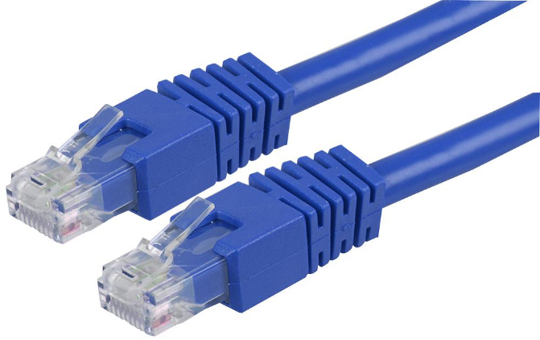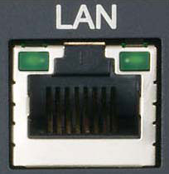
Steps:
- Plug one end of the cable into your computer or printer.
- Plug the other end into a network switch port.
- The port light will turn green or amber to show activity.
- You will be made aware if you require a static IP or DHCP. Depending on this, follow the instructions previously in the guide
Tip:
- If no lights appear, try a different port or cable.
If that doesn’t work, Contact IT Support

Connecting a Device Wirelessly
What you need:
- Wi-Fi name- SmartOffice
- Password- Provided by IT
Steps:
- Open Wi-Fi settings on your laptop/phone.
- Select SmartOffice from the list of networks.
- Enter the password
- Wait for the device to show "Connected".
How do you know it worked?
It should appear like this.
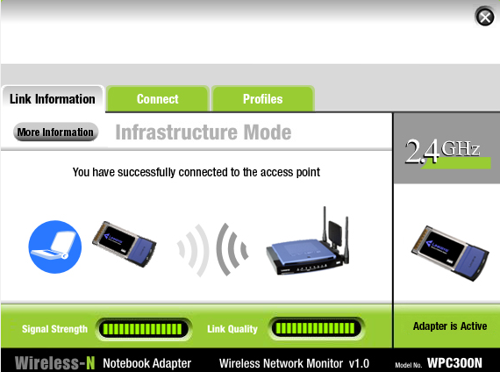
Tip:
- If the password fails, check for capital letters.
- If Wi-Fi signal is weak, move closer to the router where possible.
- If the device asks for security type, choose WPA2.
If that doesn’t work, Contact IT Support

IoT Devices

Adding IoT Devices
Steps:
- Power on the IoT device.
- Open its Network Settings.
- Select SmartOffice Wi-Fi.
- Enter the password
- Leave IP settings on Automatic (DHCP).
- In the IoT Server field, enter:
192.168.25.1
- Save settings.
- Wait until the IoT Server shows the device as Online.
How do you know it worked?
It should appear like this
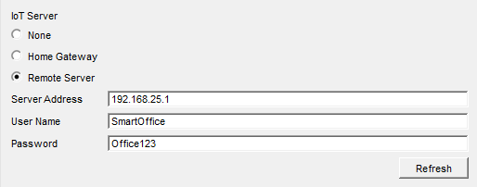
Tip:
- Ensure the IoT Server is powered on.
- Make sure Wi-Fi signal reaches the IoT device.
- Restart the device if it does not appear in the IoT app.
If that doesn’t work, Contact IT Support

Using the IoT Management App
- Open the IoT Monitor App on your workphone.
- Make sure you are connected to SmartOffice Wi-Fi.
- Log in (if login is required).
- The app will show a list of all IoT devices:
  - Coffee machine
  - Fan
  - Light
  - Motion sensor
- Select a device to perform actions
Common IoT App Features
Feature | What it does
Device Status | Shows if a device is online or offline
Control Button | Turns the device on/off
Sensor Data | Shows temperature, motion, or other readings
Automation | Schedules or triggers behaviours
How do you know it worked?
It should appear like this
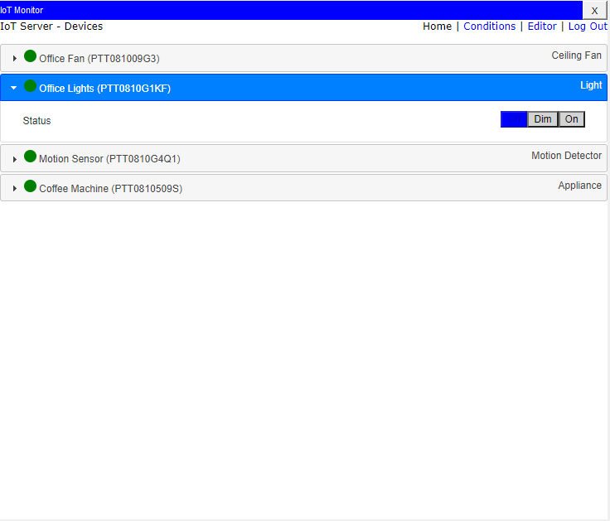 If that doesn’t work, Contact IT Support

